How to build a DIY 3D Printer step by step –

**DIY 3D Printer:** With this file you can make your own DIY 3D Printer projects by **assembling scratch parts** with Arduino board

.

This 3D Printer technology is playing a very important role in the 21st century. Maybe everyone knows about 3D Printers. If you don’t know then don’t worry, I will explain everything here so you don’t need to go to another place

In this article, you can learn the introduction of 3D Printer and you can also make your own 3DPrinter by following below step. This 3D Printer you can make it for your school or college projects for science exhibition.

I made this 3D Printer approx cost of **~rs10000**

Table of Contents[](https://www.creativitybuzz.org/diy-3d-printer/)

* [What is a 3D Printer?](https://www.creativitybuzz.org/diy-3d-printer/#What_is_a_3D_Printer)
* [How 3D Printer Work?](https://www.creativitybuzz.org/diy-3d-printer/#How_3D_Printer_Work)
* [Types of 3D Printer](https://www.creativitybuzz.org/diy-3d-printer/#Types_of_3D_Printer)
* [Application of 3D Printer](https://www.creativitybuzz.org/diy-3d-printer/#Application_of_3D_Printer)
* [DIY 3D Printer Homemade](https://www.creativitybuzz.org/diy-3d-printer/#DIY_3D_Printer_Homemade)
  + [Step:1 3D Printer Parts](https://www.creativitybuzz.org/diy-3d-printer/#Step_1_3D_Printer_Parts)
    - [3D Printer Arduino Kit](https://www.creativitybuzz.org/diy-3d-printer/#3D_Printer_Arduino_Kit)
    - [Extruder](https://www.creativitybuzz.org/diy-3d-printer/#Extruder)
    - [Hot end](https://www.creativitybuzz.org/diy-3d-printer/#Hot_end)
    - [Power Supply](https://www.creativitybuzz.org/diy-3d-printer/#Power_Supply)
    - [PLA Filament for DIY 3D Printer](https://www.creativitybuzz.org/diy-3d-printer/#PLA_Filament_for_DIY_3D_Printer)
  + [Step:2 Axis of 3D Printer](https://www.creativitybuzz.org/diy-3d-printer/#Step_3_Axis_of_3D_Printer)
  + [Step:3 Y-Axis Making](https://www.creativitybuzz.org/diy-3d-printer/#Step_4_Y-Axis_Making)
  + [Step:4 Bed Making](https://www.creativitybuzz.org/diy-3d-printer/#Step_5_Bed_Making)
  + [Step:5 X-axis Making](https://www.creativitybuzz.org/diy-3d-printer/#Step_6_X-axis_Making)
  + [Step:6 Z-axis Making](https://www.creativitybuzz.org/diy-3d-printer/#Step_7_Z-axis_Making)
  + [Step:7 Attach X & Z-axis with Y-axis](https://www.creativitybuzz.org/diy-3d-printer/#Step_8_Attach_X_Z-axis_with_Y-axis)
  + [Step:8 Extruder Making](https://www.creativitybuzz.org/diy-3d-printer/#Step_9_Extruder_Making)
  + [Step:9 Hot end Fixing](https://www.creativitybuzz.org/diy-3d-printer/#Step_10_Hot_end_Fixing)
  + [Step:10 Insert PLA Filament](https://www.creativitybuzz.org/diy-3d-printer/#Step_11_Insert_PLA_Filament)
  + [Step:11 Wiring Diagram of DIY 3D Printer](https://www.creativitybuzz.org/diy-3d-printer/#Step_12_Wiring_Diagram_of_DIY_3D_Printer)
  + [Step:12 Software for DIY 3D Printer](https://www.creativitybuzz.org/diy-3d-printer/#Step_13_Software_for_DIY_3D_Printer)
* [Conclusion:](https://www.creativitybuzz.org/diy-3d-printer/#Conclusion)

## WHAT IS A 3D PRINTER?

These machines are used to convert the 3D designs that a person can do with the help of the computer into a real object. To attain this, they use**liquid plastic** (or other materials) rather of the ink to which we are habituated, which after the impression solidifies and made the object.

They are usually big machines that can cost approx five thousand dollars, but technological progress is making them available to the general public easily.

An object that made in 3D Printer shown in below image- 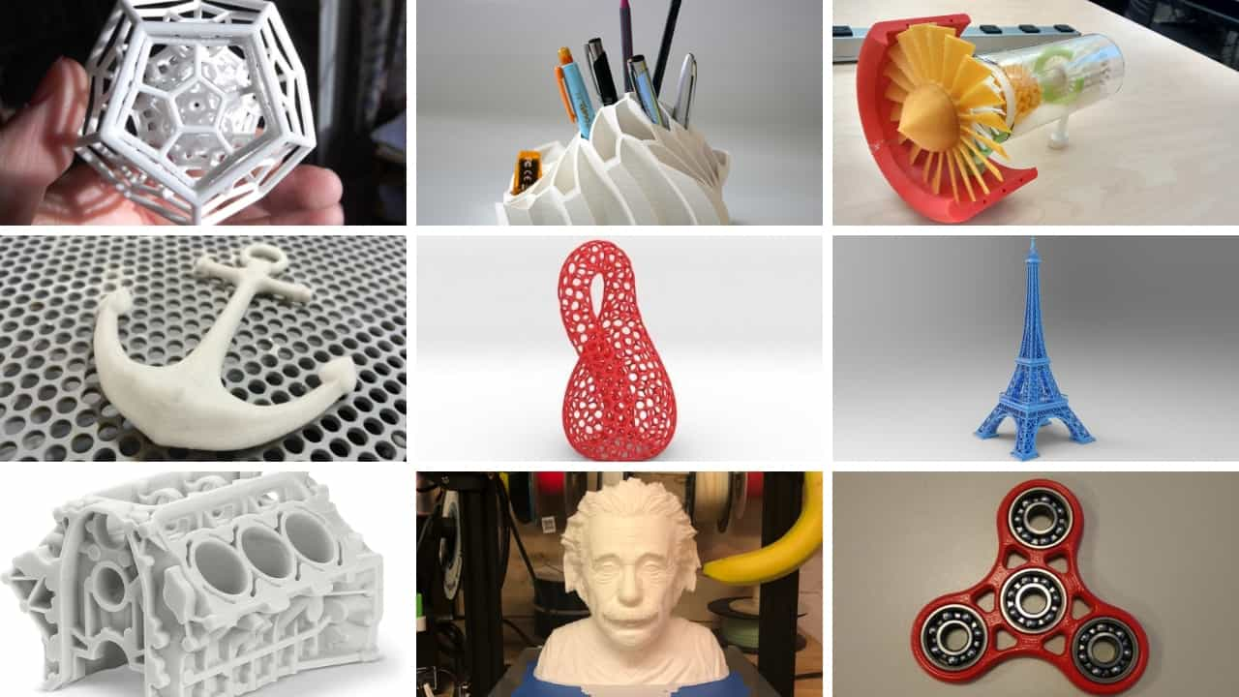

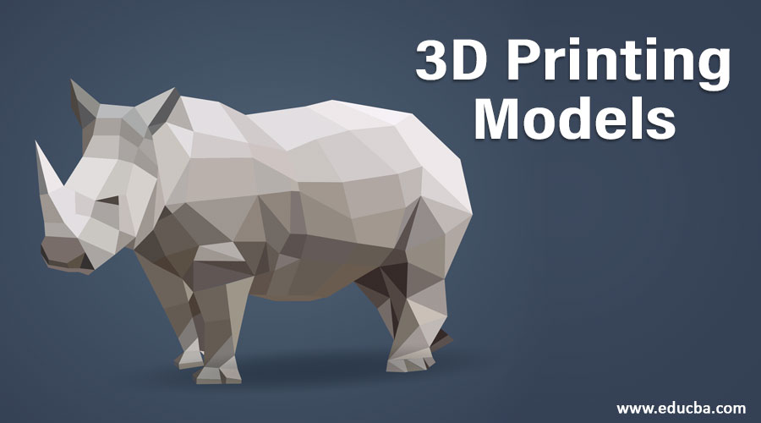

## HOW 3D PRINTER WORK?

There are various ways to get it, but the most common is to disjoin the 3D model into a very thin layer that is printed one on top of the other, and after that fix them, we have a 3D object.

To make it better sympathize, let’s check at one of the most used processes, stereo lithography: the printer produces a thin layer of resin and “draws” a thin straight section of the product with a laser beam. That laser solidifies the pattern he drew and sticks it to the next layer of resin, and so the process is repeated **layer by layer**. At the end of all that resin comes forth the 3D object designed.

You can see below image for better understanding.

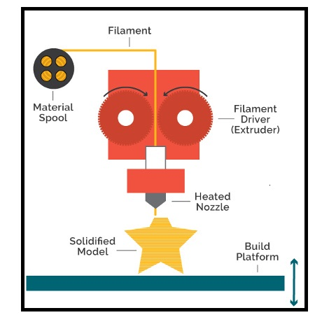

This is not the only method and different materials like as dust or metals can be used, or even **liquid plastic material that solidifies** when leaving the printer, but the concept of layers constantly implement.

3D Printing objects are commonly measured in centimeters (it is a small object). But some printers can reach up to several meters. It is also a slow process that needs solitaire: for a 100-gram object, something build complex objects may require several hours. Finally, mention that the materials they use in the 3D Printer are not cheap.

## TYPES OF 3D PRINTER

When you ask me what type of 3D printer is great, I constantly answer with another question: What do you wish to print? You could say that there is no one type of printer great than another.

All Printers has its **advantages** and **disadvantages**. The different technologies **are complementary** and each one put up something different. For this reason, I have made a list in which the different types of printers are classified:

* **Extrusion** ([Fused Deposition Modeling](https://www.creativitybuzz.org/fused-deposition-modeling/))
* **Resin** (Photo polymerization)
* **Powder** (Powder)
* **Others**

Here we are making the Extrusion 3D Printer.

## APPLICATION OF 3D PRINTER

* **Rapid prototypes** of industrial products
* **Medical Prostheses**
* Create your own **ornaments** and then paint them
* **Figures** of your favorite character
* The very fast **Manufacturing process**

## DIY 3D PRINTER

If you are planning to make to DIY 3D PRINTER than follow this below step to make 3D Printer --

### STEP: 1 3D PRINTER PARTS

* **3D Printer Arduino kit**
* **Hot end**
* **Extruder**
* **Stepper motor (4 no**
* **12 Volt 10 Amp Power Supply**
* **PLA Filament 1.75 mm5 x 8 Shaft Coupler(4 no)**
* **Trapezoidal Threaded Screw(2 no 150 mm length**
* **Trapezoidal Threaded Screw(1 no 200 mm length)**
* **Pencil (or Smooth road)**
* **8 x 22 x 7 mm Radial Bearing(5 no)**
* **Limit Switch(3 no) Acrylic Sheet**
* **Wooden Block**

#### 3D PRINTER ARDUINO KIT

* **RAMPS 1.4**
* **Mega 2560 R3 board**
* **A4988 Driver**

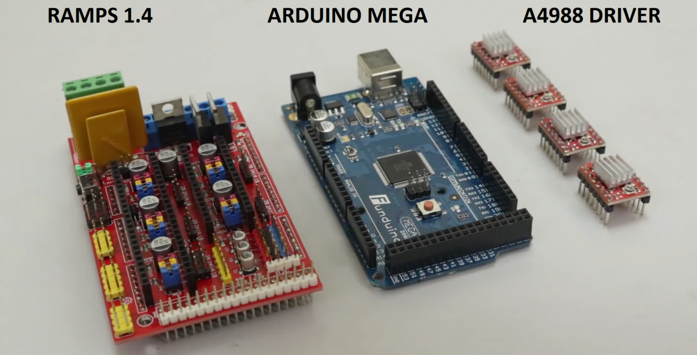

#### 

#### EXTRUDER

This Part is very important in 3D Printer. The extruder is used for the **pushes** the plastic filament inside the hot end nozzle.

There number of small component there in the extruder. See the below image

### Screenshot_20190420-111927-1.png

#### HOT END

This Part is**melting** the plastic filament, and this melted plastic goes inside the hot nozzle. It will solidify on the hotbed. A hot end consists of the below parts:

* Cooling Fan
* Nozzle
* Heater
* Temperature Sensor
* Teflon Tubing

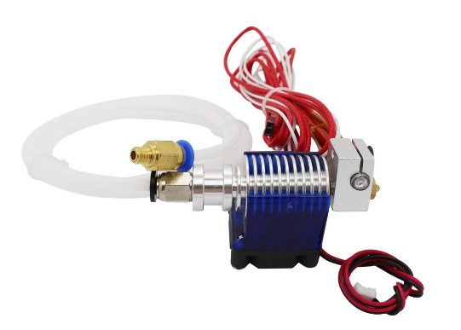

#### POWER SUPPLY

Here we use **12V and 10 amp** Power supply. Please keep in mind that you must use**thick gauge** wire for output. Because heater consumes lots of power so high current flow through this wire. If you use thin wire than it chances to heat up and it will be fire.

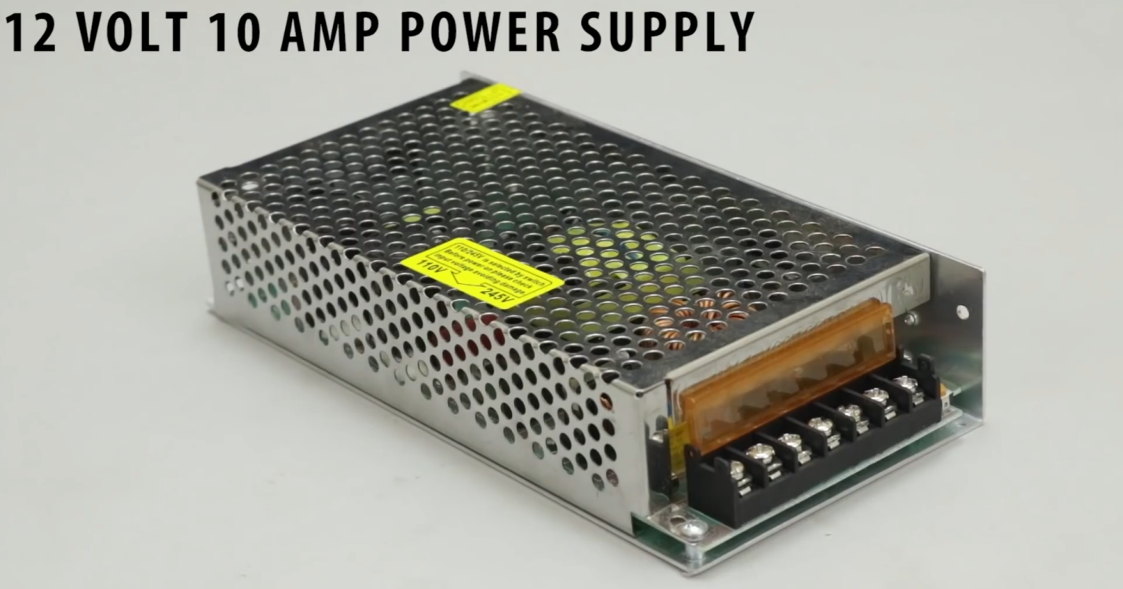

#### PLA FILAMENT FOR DIY 3D PRINTER

This Plastic filament is passing through the hot end nozzle and solidified on the bed of the machine. There is a different color of filament available in the market. you can choose what you like.

**Required Features of PLA Filament:**

● It must have good **quality** PLA material  
● Work with all type of 3D printers  
● PLA is a biodegradable filament which is made from renewable resources, like corn starch, tapioca roots, chips or starch, or sugarcane  
●It must permit higher print speed, more accurate locating of material with easy cooling.  
● PLA smells out like cotton candy perfume when it is used

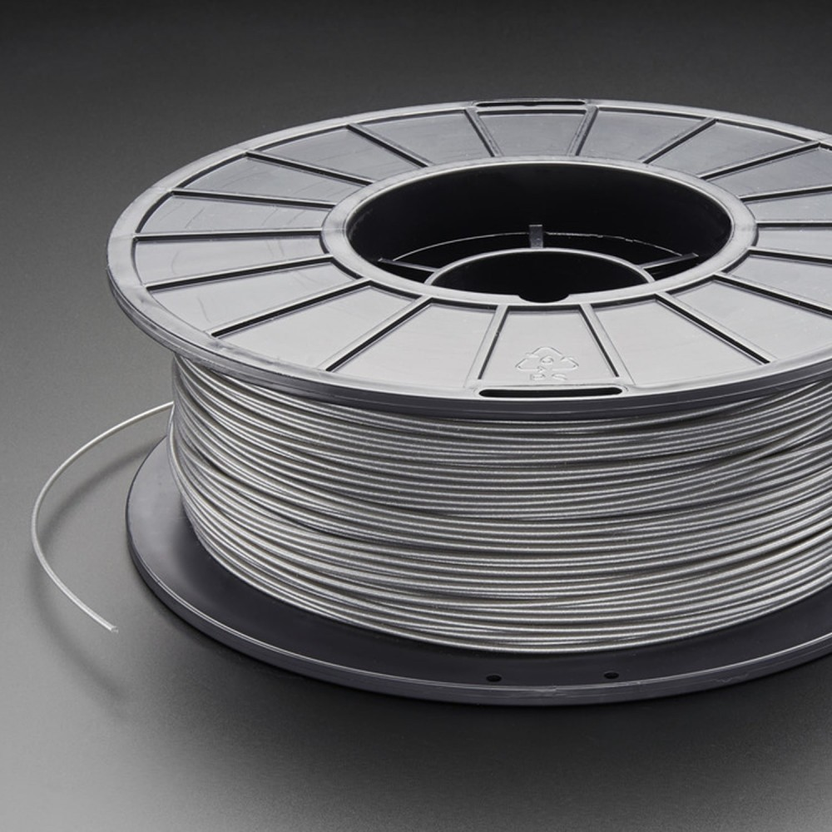

### STEP: 2 AXIS OF 3D PRINTER

3D Printer is working on **3 Axis, X, Y, Z**. The main thing to learn in the 3D Printer is his axis.

If your axis is not properly managed than your machine is not working better. Here I will show you an image of the 3D Printer Axis.

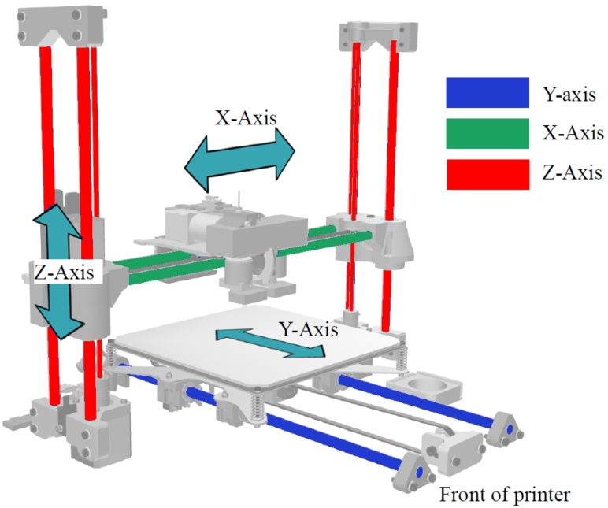

You can see that from image

**X-Axis:** It Controls the movement of the nozzle left or right

**Y-Axis:** Control the movement of Bed

**Z-Axis:** It Controls the movement of the nozzle up and down

### STEP:3 Y-AXIS MAKING

The Y-axis controls the movement of the bed. To make a Y-axis arrangement we need 2 stepper motor. Follow the below step to make it.

1. Take the two acrylic sheet. Make a hole of the size of one hole is **8 mm** and another hole size is equal to an *outer diameter of bearing (****22 mm****)*.
2. Stick this acrylic sheet with a wooden plate of length **22 cm**
3. Insert the Threaded Screw of length **150 mm** inside the bearing
4. Join the Stepper motor with the threaded screw by **Coupling.**
5. Take a **Syringe** and cut both the end of it
6. Cut both ends of a Ball pen cap
7. Insert this cap into the syringe, so this is working like linear bearings. This is made because of the smooth movement of smooth toad when the operation is done.
8. Now insert the big size pencil inside the small hole of acrylic. You can also use a plain rod of diameter**8 mm**
9. Our one parts of Y-axis done
10. **Repeat** the above 9 steps and make the same frame
11. Now join both the parts by 3 pencils attach at the side of wooden plate
12. Our Y-axis ready

### STEP: 4 BED MAKING

3D Printing is done on a bed. Keep in mind that bed must be at the proper leveling. If it is not in level than your object will not be accurate.

We can also measure the leveling of bed with the help of your Smartphone or a leveling tool. You can adjust the leveling of bed by nut fitted over the spring\\

Follow the below step for making bed arrangement for 3D Printer.

1. Take wooden plate as per your size and fix on the nut of a threaded screw
2. Make a hole of size **2 mm** on that wooden plate
3. Put the acrylic sheet on the wooden plate and fix it with the help of 4  screw
4. Insert 4 screw on acrylic sheet
5. Add Ball pen spring on that 4 screws. You can adjust the leveling of bed by this spring
6. Now tight these spring by a nut
7. Check your leveling by Smartphone or by leveling tool until it shows 0 reading. If it does not show than adjust the nut of that 4 spring.

### STEP: 5 X-AXIS MAKING

The x-axis is very simple to make. You can make it by reading the instruction given in y-axis.

Here the length of Threaded screw is **200 mm**.

One thing new is you have to choose the wooden plate length is **27cm**

### STEP: 6 Z-AXIS MAKING

This Z-axis is made on the X-axis with the help of **Old DVD Writer Parts**.

Z-axis is used for the **up and down** the movement of 3d printer nozzle.

1. Attach the wooden block on the x-axis as per image
2. Take an old DVD Writer from the Computer shop
3. Attach the parts of DVD Writer as per above image
4. Our Z-axis is ready to perform

### STEP: 7 ATTACH X & Z-AXIS WITH Y-AXIS

Now its time to join X & Z-axis with Y-axis. For that, you have to attach two wooden blocks on the x-axis.

Attach this full assembly with Y-axis by fevistick or screw.

### STEP: 8 EXTRUDER MAKING

To make an Extruder for 3D Printer is very easy. Because you only have to assemble the parts of an extruder.

When your extruder is ready at that time you can install it in our frame of 3D Printer.

### STEP: 9 HOT END FIXING

After Extruder it’s time to fix hot end assembly with DIY 3D Printer. You need to make one L shape parts for fixing the hot end with the z-axis assembly.

### 

### STEP: 10 INSERT PLA FILAMENT

PLA Filament is inserted inside the Extruder. So when Stepper motor is rotated at that time filament is come in hot end nozzle through the extruder.

The diameter of the nozzle is equal to the diameter of the PLA Filament.

### STEP: 11 WIRING DIAGRAM OF DIY 3D PRINTER

DIY 3D Printer wiring diagram is very easy if you follow the instruction and follow the below image wiring diagram.

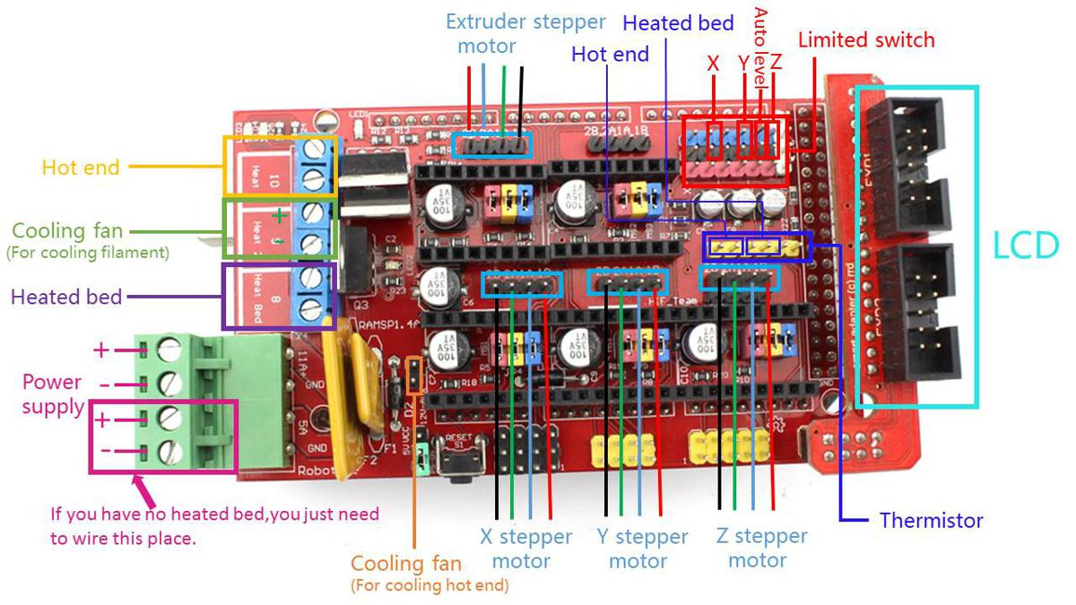

Below diagram is with LCD & Hotbed. This LCD is not necessary if you have a laptop. but your use of 3D Printer is high than every time connect the laptop with 3D Printer is not a good idea.

In LCD you can get the slot for micro SD card. So you can feed that G-code through the SD card.

### STEP: 12 SOFTWARE FOR DIY 3D PRINTER

Main things to do in 3D Printer are software. There is a different type of software available for 3d printing. Here we use 4 software for 3d printing listed below.

1) ARDUINO:

This software is used to upload the code on ARDUINO board

And the code is MARLIN firmware.

2) CAD software:

This software is used for making a 3D object. The file is

Saved as STL format.

3) CURA:

This software is slicing software in which file is saved as G-code.

4) PRONTERFACE:

This software directly controls the 3D printer. The print

Command is given through this software.

## CONCLUSION:

3D printing, like modeling or three dimensional scanning is a creation tool among other things, but what most distinguishes it is **its potential to create an almost unlimited number of shapes**. As with every tool, you need to master it, to take advantage of its abilities, but also know its limits.

Designers use 3D printers **to quickly create product models and prototypes**, but they're increasingly being used to make final products.